**Stage Design**

In addition to enemies, traps and gimmicks will spice up the levels, often enabling or complicating shortcuts.

**Traps:**

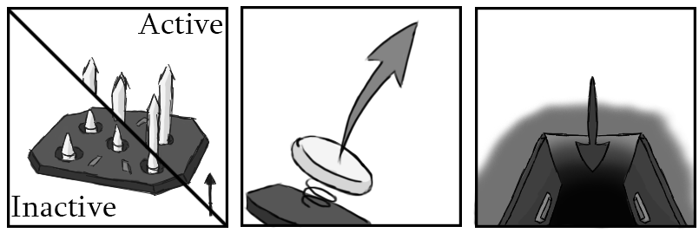

Figure - Traps: Spike, Spring, Trapdoor

For example, the humble spike trap. Two types exist, one being timed, triggering based on a customisable cycle, and the proximity one, triggering after being run over. The proximity one will have an adjustable delay, to allow or disallow quick reactions to save yourself, and a cooldown to prevent is triggering immediately after firing.

This cooldown could work well with the shrew caravan for example, taking out the mother and causing the babies to charge. Traps that hurt you will also hurt enemies that enter the range, and enemies will be able to trigger certain traps. Other traps to impact combat could include sticky floors that slow you down, flame traps that spew fire a distance away, and trapdoors that open to reveal new, usually detrimental, parts of the level when stepped on. Gimmicks like springs (bounces the player, usually up) or fans (pushes the player) will alter platforming.

**Stage Gimmicks:**

Buttons that link objects together, like opening a set of gates can create action sequences easily, and other gates could require beating certain enemies to open.

**Weapon and Level Interactions:**

Another idea is key level beats that utilise a certain weapon to great effect. For example, the shockwave effect of the shield could be used to push enemies off a narrow bridge into hazards below, or a wall-run-able wall could curve around to reveal a secret area with the daggers. Multiple weak enemies like dizzy chargers could be placed after a hard area to recover health using the scythe, accessible via zipline, and a medium sized gap could be crossed by grappling a Lobuzz using the hook shot.

Given how the game is based around speed, shortcuts, like the Lobuzz gap cut, detours, like the healing area for the scythe, and alternate paths matter. Risk vs reward style gameplay, where the reward is a time save for pulling off a trick (or choosing to not slow down and heal) is great for speed-running, whereas an “apples and oranges” choice between alternate routes (combat or platforming for example) lets players play to their strengths. Leader boards to share best times should be considered.